Pizza Sales Queries and outputs

A KPI’s

1. Total Revenue

select SUM(total_price) as Total_Revenue from pizza_sales

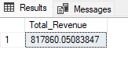

1. Average Order Value

select SUM(total_price)/count(distinct(order_id)) as AVERAGE_ORDER_VALUE from pizza_sales

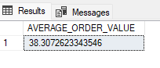

1. Total Pizza Sold

select sum(quantity) as TOTAL_PIZZA_SOLD FROM pizza_sales

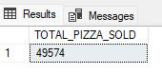

1. Total Orders Placed

select count(distinct(order_id)) as Total_Orders from pizza_sales

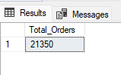

1. Average Pizza Per Order

select cast(cast(sum(quantity) as Decimal(10,2))/cast(count(distinct(order_id)) as Decimal(10,2)) as Decimal(10,2)) as Average_Pizza_Per_Order from pizza_sales

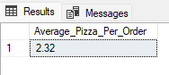

1. Total order Day wise

select Datename(DW, order_date) as order_day , count(distinct(order_id)) as Total_Orders from pizza_sales

group by Datename(DW, order_date)

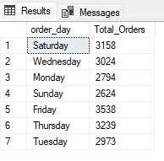

1. Total Order Month wise

select Datename(Month , order_date) As Order_Month, Count(Distinct(order_id)) As Total_Orders from pizza_sales

group by Datename(Month , order_date)

order by Total_orders desc

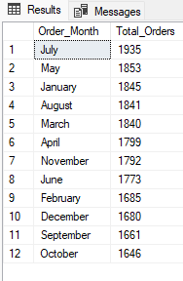

1. Total Sales and Percentage of Total_Sales by Pizza Category

select pizza_category, sum(total_price) as Total_Sales , cast(sum(total_price)*100/ (select sum(total_price) from pizza_sales) as Decimal(10,2)) as Percentage_of_Total_Sales from pizza_sales group by pizza_category

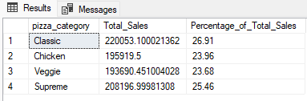

1. Total Sales and Percentage of Total Sales by Pizza Sizes

select pizza_size, sum(total_price) as Total_Sales , cast(sum(total_price)*100/ (select sum(total_price) from pizza_sales) as Decimal(10,2)) as Percentage_of_Total_Sales from pizza_sales group by pizza_size

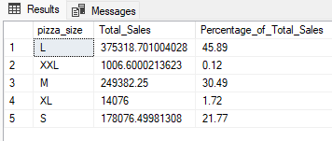

1. Top 5 Best Sellers by Revenue

select Top 5 pizza_name , sum(total_price) As Total_Revenue from pizza_sales

group by pizza_name

order by Total_Revenue Desc

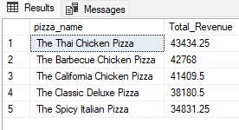

1. Worst 5 Pizza by Revenue

select Top 5 pizza_name , sum(total_price) As Total_Revenue from pizza_sales

group by pizza_name

order by Total_Revenue

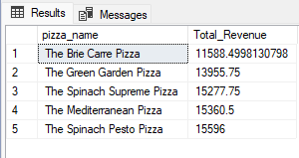

1. Top 5 Best Sellers by Quantity

select Top 5 pizza_name , sum(quantity) As Total_Quantity from pizza_sales

group by pizza_name

order by Total_Quantity Desc

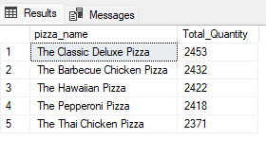

1. Bottom 5 Pizzas by Quantity

select Top 5 pizza_name , sum(quantity) As Total_Quantity from pizza_sales

group by pizza_name

order by Total_Quantity

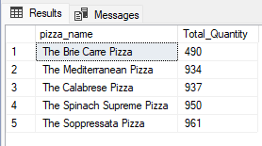

1. Top 5 Pizzas with respect to orders

select Top 5 pizza_name , count(distinct(order_id)) As Total_Orders from pizza_sales

group by pizza_name

order by Total_Orders Desc

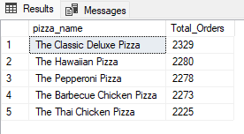

1. Bottom 5 Pizzas with respect to orders

select Top 5 pizza_name , count(distinct(order_id)) As Total_Orders from pizza_sales

group by pizza_name

order by Total_Orders

